Part A

Develop software to perform a DFS starting at Dallas (always choose the edge with the smallest mileage). Identify the discovery edges and the back edges. What is the total distance travelled on the discovery edges?

Part B

Develop software to perform a BFS starting at Dallas (always choose the edge with the smallest mileage). Identify the discovery edges and the cross edges. What is the total distance travelled on the discovery edges?

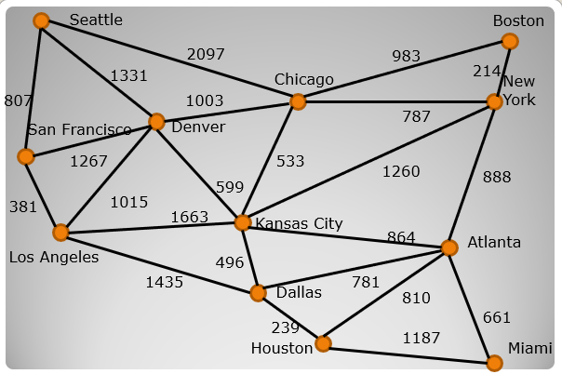

Work with one partner from your project 2 team.

Due April 9th